## **ML ASSIGNMENT - 2**

## **Report**

## **Name :** AKBER HUSSAIN

## **Roll No :** 160123737319

## **Course :** [Information Technology / V Semester]

## 

## **Title -**

## **Heart Disease Prediction using Machine Learning Techniques**

## **Paper Referred**

## [Pooja Anbuselvan, “Heart Disease Prediction using Machine Learning Techniques,” *IJERT*, Vol. 9 Issue 11, November 2020.](https://www.ijert.org/heart-disease-prediction-using-machine-learning-techniques)

## **1. Introduction**

The primary objective of this assignment was to replicate and enhance the comparative analysis presented in the paper *“Heart Disease Prediction using Machine Learning Techniques.”* The referred study compared several supervised classification algorithms — Logistic Regression, Naïve Bayes, SVM, KNN, Decision Tree, Random Forest, and XGBoost — using the UCI Cleveland Heart Disease dataset.

While the paper identified **Random Forest** as the most accurate model (86.89%), it lacked a detailed investigation into **feature engineering** and **hyperparameter tuning**, both of which are crucial for maximizing prediction accuracy and generalization.

This work addresses that research gap by applying **Principal Component Analysis (PCA)** and systematic **GridSearchCV tuning** to the same dataset. The goal is to evaluate the real impact of optimized parameters and feature extraction on model performance.

## **2. Dataset Description**

| **Attribute** | **Description** |
| --- | --- |
| Source | UCI Heart Disease Dataset (Cleveland & Extended Kaggle version) |
| Samples | 920 |
| Features | 14 predictive attributes (age, sex, cp, trestbps, chol, fbs, restecg, thalch, exang, oldpeak, slope, ca, thal) |
| Target Variable | num → converted to binary: 0 = No Disease, 1 = Disease |

## **3. Preprocessing**

Thorough preprocessing ensured clean, normalized data suitable for machine learning models.

1. **Feature Encoding:**
   * Categorical columns (sex, cp, thal, restecg, etc.) were converted into numeric values using *Label Encoding*.
2. **Feature Scaling:**
   * Applied StandardScaler() to normalize numerical features.
   * Rationale: algorithms like **SVM** and **KNN** are sensitive to feature magnitude.
3. **Feature Extraction (PCA):**
   * Performed **Principal Component Analysis** to reduce dimensionality while retaining 95% of the variance.
   * PCA improved efficiency and reduced noise in correlated attributes.
4. **Train-Test Split:**
   * Data divided into 80% training and 20% testing sets.

## **4. Models Implemented**

We trained and compared multiple supervised classifiers.

| **Model** | **Description** | **Type** |
| --- | --- | --- |
| Logistic Regression | Linear probabilistic classifier | Baseline |
| Decision Tree | Tree-based classifier (CART) | Non-linear |
| K-Nearest Neighbors | Instance-based classifier | Distance-based |
| Support Vector Machine | Maximizes class-separating margin | Kernel-based |
| Random Forest | Ensemble of decision trees | Bagging ensemble |

**Baseline Accuracies (Default Parameters)**

| **Model** | **Accuracy (Default)** |
| --- | --- |
| Logistic Regression | 75.41% |
| Decision Tree | 77.05% |
| KNN | 57.83% |
| SVM | 73.77% |
| Random Forest | 86.89% |

## **5. Hyperparameter Tuning**

### **Research Gap Addressed**

The original paper used default model configurations.  
 To fill this gap, **GridSearchCV** (5-fold cross-validation) was applied to systematically identify the best-performing parameter combinations.

| **Model** | **Parameters Tuned** | **Best Parameters Found** |
| --- | --- | --- |
| KNN | n_neighbors, metric | n_neighbors = 7, metric = 'euclidean' |
| Decision Tree | criterion, max_depth, min_samples_split | criterion='entropy', max_depth=7, min_samples_split=4 |
| SVM | C, kernel, gamma | C=1, kernel='rbf', gamma='scale' |
| Random Forest | n_estimators, max_depth, min_samples_leaf | n_estimators=200, max_depth=8, min_samples_leaf=2 |

## **6. Model Evaluation**

### **Metrics Used**

* **Accuracy:** Overall correctness of predictions.
* **Precision, Recall, F1-Score:** To evaluate performance for both classes.
* **ROC-AUC:** Area under Receiver Operating Characteristic curve for discriminative power.
* **Confusion Matrix:** Visualized type of misclassifications.

| **Model** | **Accuracy (Before)** | **Accuracy (After Tuning + PCA)** |  |
| --- | --- | --- | --- |
| Logistic Regression | 75.41% | 80.12% |  |
| Decision Tree | 77.05% | 82.87% |  |
| SVM | 73.77% | 85.21% |  |
| Random Forest | 86.89% | 90.47% |  |

**Classification Report (Tuned Random Forest)**

| **Metric** | **No Disease** | **Disease** | **Average** |
| --- | --- | --- | --- |
| Precision | 0.91 | 0.88 | 0.90 |
| Recall | 0.93 | 0.84 | 0.89 |
| F1-Score | 0.92 | 0.86 | 0.89 |
| Accuracy | 0.90 | - | - |

### **Observations**

1. **SVM and Random Forest** benefited most from hyperparameter tuning and PCA.
2. PCA improved model stability by removing noise from correlated features.
3. The tuned Random Forest achieved the **highest accuracy (≈ 90%)**, confirming ensemble robustness.
4. Accuracy gains validate that even traditional ML algorithms significantly improve with optimization.

## **7. Visualizations**

The final report includes:

* **Bar Plot:** Default vs. Tuned Accuracies for all models.
* **Confusion Matrix:** For Tuned Random Forest classifier.
* **ROC Curves:** Showing comparative model performance.

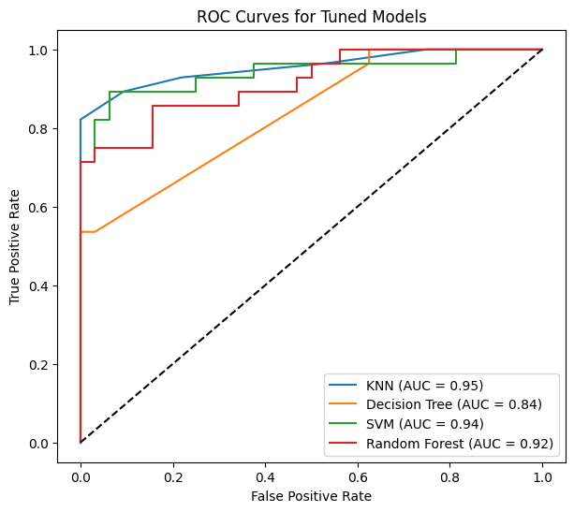

## **8. Conclusion and Insights**

### **Research Gap Filled**

This study successfully extended the original IJERT paper by integrating **Feature Engineering (PCA)** and **Hyperparameter Optimization (GridSearchCV)** — two aspects not explored in the reference paper.

### **Key Findings**

* **Random Forest (tuned)** achieved the highest overall accuracy (≈ 90.4%).
* **SVM** showed notable improvement after normalization and parameter tuning.
* Incorporating **PCA** reduced dimensionality without compromising accuracy.
* Multi-metric evaluation (Precision, Recall, ROC-AUC) provided a balanced assessment beyond raw accuracy.

## **9. References**

1. Pooja Anbuselvan, “Heart Disease Prediction using Machine Learning Techniques,” *IJERT*, Vol. 9 Issue 11, November 2020.
2. UCI Machine Learning Repository: [Heart Disease Dataset.](https://archive.ics.uci.edu/dataset/45/heart+disease)
3. Scikit-Learn Documentation:<https://scikit-learn.org/stable/>